ANNEX 8. Visual Guide for Participants in the “Bunica și Bunelul Fest” 2026 Festival

How to film, take photographs and submit your materials, step by step
This guide provides practical advice on preparing photographs, videos and written materials so that they are clear, respectful, easy to review and suitable for publication. It supports participants throughout the process of filming, taking photographs, naming files and submitting materials, including those who may need technical assistance or have limited access to digital tools.
Important: the activity titles used in this guide must be identical to those in the Festival Regulations:
- Online competitions: “Miss & Mister Bunica și Bunelul”, “On the Wings of Dance” and “The Song in Our Hearts”.
- Themed exhibitions: “The Beauty of the Silver Years” and “What Skilled Hands Can Make”.
- Themed activities: “A Taste of Childhood: Family Recipes and Autumn Dishes” and “The Health Formula: Simple Habits for an Active Life”.
- When submitting materials, please use these exact titles in the “Activity” field and in the email subject line so that the organisers can identify your submission easily.
- How to record a good-quality video using your phone
Before filming:
- Clean the phone camera carefully with a soft cloth, such as a glasses-cleaning cloth. A dirty or dusty lens will make the image look blurred.
- Check your phone’s battery level and available storage. Make sure the phone is sufficiently charged for filming and that there is enough free space to save the video.
- Prepare a simple script. Write down or print the words you intend to say. Plan what you will say or do and in what order, so that you do not forget any important details.
Filming:
- Hold the phone horizontally, in landscape orientation. A horizontal video is better suited to Facebook.
- Avoid holding the phone in your hand while filming. Place it on a tripod or support it securely against a stack of books, a box or another stable object. This will prevent camera shake and produce a clearer, steadier video.
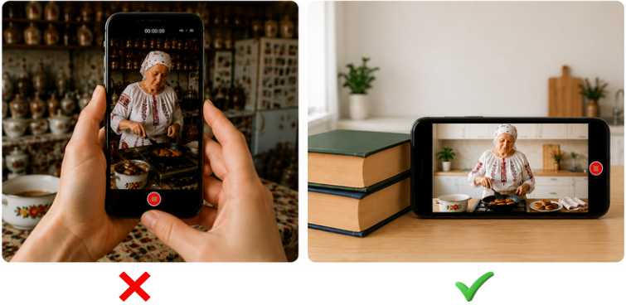
- Use the main camera on the back of the phone rather than the front-facing camera.
- Use good lighting. Film during the day, near a window or outdoors. Do not stand with your back to a window, as backlighting will make your face appear dark or silhouetted. Make sure the light source is in front of you.
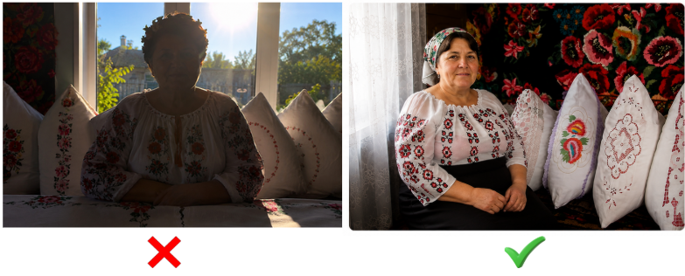
- Ensure clear sound. Turn off the television and radio, and avoid windy or noisy locations.
- Set the focus. Tap the person or object you want to highlight on the phone screen. The phone will automatically adjust the focus at that point.
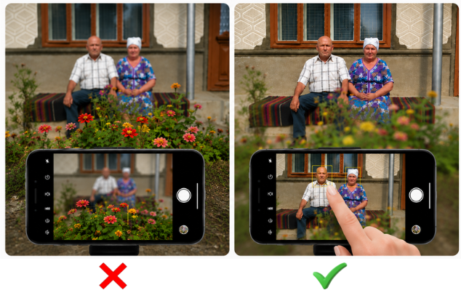
- Position the person or object close to the centre of the screen so that the image is well composed.
- Video length:
• Follow the maximum duration stated in the relevant activity annex;
• “Miss & Mister Bunica și Bunelul”: maximum 2 minutes;
• “On the Wings of Dance”: maximum 2 minutes;
• “The Song in Our Hearts”: maximum 3 minutes;
• “A Taste of Childhood: Family Recipes and Autumn Dishes”: maximum 2 minutes;
• “The Health Formula: Simple Habits for an Active Life”: maximum 1 minute when submitting a video.
- For a more professional result, you may use a video-editing application.
Learn how to create engaging videos using CapCut:
https://www.facebook.com/BunicaBunelulFest/videos/1070058414649801/
2. How to take good-quality photographs using your phone
Before taking photographs:
- Clean the phone camera carefully with a soft cloth, such as a glasses-cleaning cloth. A dirty or dusty lens will make the image look blurred.
- Check your phone’s battery level and available storage. Make sure the phone is sufficiently charged and that there is enough free space to take and save several photographs.
- Choose the location, person or object you want to photograph in advance. When photographing a person, consider suitable clothing and how they should pose, for example standing, sitting or smiling.
Taking the photographs:

- Take photographs during the day using natural light. Avoid dark rooms. When indoors, do not position the person with their back to a window. When outdoors, do not position them with their back to the sun. Backlighting will make the face appear dark or silhouetted. Make sure the light source is in front of the person.
- Make sure the person or object is well lit and not in shadow.
- Choose a simple background:
- For portraits, photograph the person against a clean wall or in a location without too many objects in the background. Avoid rubbish bins, excessive decorations and cluttered spaces.

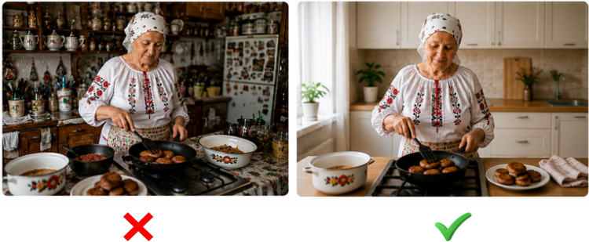

- For handmade items, place the object on a clean surface, preferably a white table, in a well-lit area.
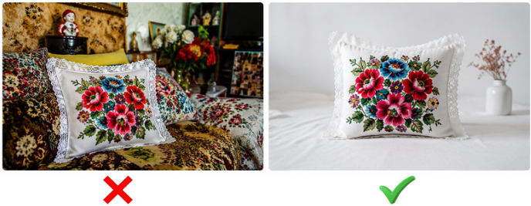

- For “A Taste of Childhood: Family Recipes and Autumn Dishes”, place the food on a clean, light-coloured plate. You may add a napkin, leaves, seasonal flowers or other elements suited to the autumn theme.
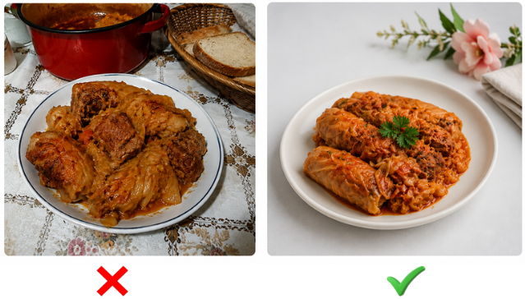
- Set the focus. Tap the person or object you want to highlight on the phone screen. The phone will automatically adjust the focus at that point.
- Position the person or object close to the centre of the screen so that the image is well composed.
Examples of a photo collage for “A Taste of Childhood: Family Recipes and Autumn Dishes”:
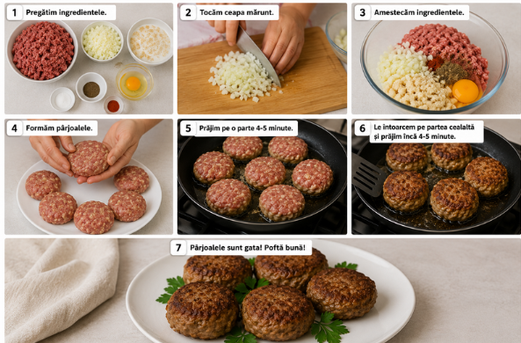

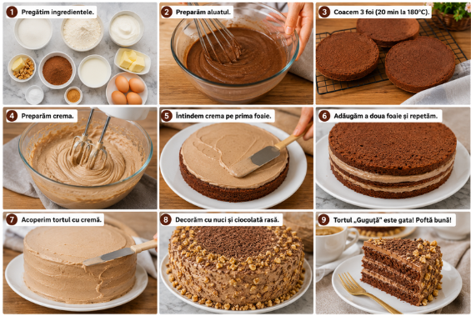

How to create a collage for “A Taste of Childhood: Family Recipes and Autumn Dishes”:
• The collage should contain between 6 and 9 photographs.
It should show the main stages of preparing the recipe and the finished dish:
- The first photograph should show the ingredients arranged separately in bowls or on plates.
- Include photographs of the most important preparation stages, such as chopping, mixing or mashing the ingredients, the order in which ingredients are added, and the cooking temperature and time.
- Include a photograph of the finished dish arranged on a plate.
Recommendation: add autumn-themed decoration, such as a napkin in warm colours, leaves, fruit, seasonal flowers or other suitable elements.
You may add a short caption to each photograph explaining what is happening at that stage, for example: “Mix the flour and eggs”, “Bake for 20 minutes at 180°C” or “The finished dish”, as shown in the example above.
Recommended application for creating the collage:
Canva: https://www.canva.com/
Step 1: Open the Canva app, if it is installed on your device, or go to https://www.canva.com/ in your browser.
Step 2: Create an account or sign in using your Google or Facebook account.
Step 3: Click “+” or “Create a design” in the top-left corner.
Step 4: Type “Collage” in the search bar and select “Photo Collage (Landscape)”.
Step 5: Select a collage template with 6, 7 or 9 spaces, depending on the number of photographs you have.
Step 6: In the menu on the left, select “Uploads”.
Step 7: Click “Upload files” and select the photographs from your phone gallery or computer. The photographs will be saved in Canva and can then be dragged directly into the collage.

When you have finished, click “Download” in the top-right corner and select JPG as the file format.
Arranging the photographs:
- You can resize and reposition the photographs within the collage until the layout looks the way you want.
- You may also add a short description to each photograph explaining what is happening at that stage.
For example: Step 1: Ingredients; Step 5: Place in the oven.
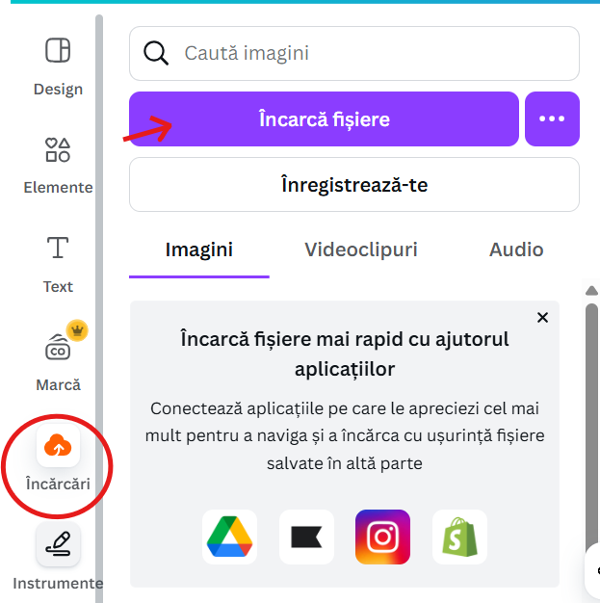
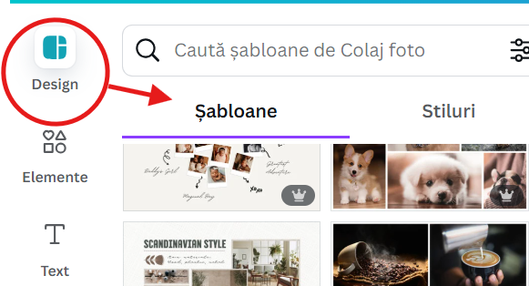
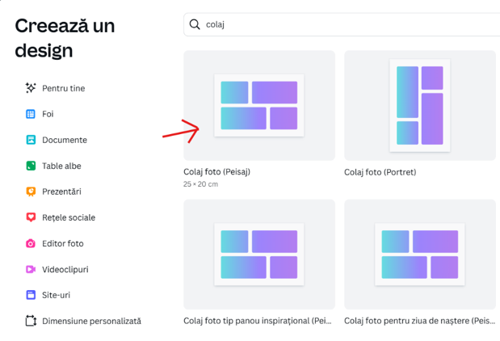

3 How to submit materials by email
If you have an email address:
- Open your email application, such as Gmail or Yahoo Mail, or go to mail.ru in your browser.
- Sign in using your email address or telephone number and enter your password.
To send a message:
Step 1: Click “Write”, “New message” or “Compose”.
Step 2: In the “To” field, enter: bunicafest@gmail.com
Step 3: In the “Subject” field, write: Submission - Name - Activity.
Examples: “Submission - Maria Popa - The Beauty of the Silver Years” or “Submission - Ion Popa - A Taste of Childhood”.
Step 4: Click the paperclip icon to attach the file, video or photographs.
Step 5: Select the file from your phone or computer, from the folder where it was saved.
Step 6: Click “Send”.
4. How to send large files over 25 MB
When a file is too large to send by email, use one of the free services below:
4.1. WeTransfer: https://wetransfer.com
Step 1: Open https://wetransfer.com.
Step 2: Click “Add your files” and select the file you want to send.
Step 3: In the “Email to” field, enter: bunicafest@gmail.com
Step 4: In the “Your email” field, enter your email address.
Step 5: Click “Transfer”.
After you click “Transfer”, the file will begin uploading and will be sent automatically to bunicafest@gmail.com. Wait until a confirmation message appears or is sent to your email address. The website is in English, but it is straightforward to use on both a phone and a computer.
A step-by-step video showing how to send a file or folder using WeTransfer is available here:
https://youtu.be/a7uoY6-6_Fw

4.2. Google Drive: https://drive.google.com
- Step 1: Open https://drive.google.com in your browser.
- Step 2: Sign in using a Gmail account and enter your Gmail address and password.
To use Google Drive, you need an email address ending in @gmail.com. If you already have one, you can access Google Drive directly. Otherwise, you can create an account free of charge at www.gmail.com.
How to send a file or folder using Google Drive:
Step 1: Click “+ New” in the top-left corner.
Step 2: Select one of the following options:
- “File upload” if you want to upload a single document, photograph, video or other file.
- “Folder upload” if you want to upload an entire folder containing several files.
Step 3: Locate the file or folder on your computer and click “Open”.
Step 4: Wait for the upload to finish. Its progress will be displayed in the bottom-right corner.
- Once the file has been uploaded, find it in the Drive file list or search for it using its name.
Step 5: Select the uploaded file or folder and click “Share”.
Step 6: Under “General access”, select “Anyone with the link”.
Step 7: Keep the permission set to “Viewer”. There is no need to grant editing access.
Step 8: Click “Copy link”, then click “Done”.
You can now send the link by email to: bunicafest@gmail.com
A step-by-step video showing how to send a file or folder using Google Drive is available here:
https://youtu.be/EVwT_xtznD4
4.3. Filemail: https://www.filemail.com/ru
Step 1: Open https://www.filemail.com/ru in your browser.
Step 2: Click “Add your files” or “Загрузите файлы”.
Step 3: Select one of the following options:
- “Add files” or “Добавить файлы” if you want to send a single document, photograph, video or other file.
- “Add folder” or “Добавить папку” if you want to send an entire folder containing several files.
Step 4: Select the required file or folder on your computer and click “Open”.
Step 5: Choose one of the two delivery options:
- “Send as email” or “Отправить как электронное письмо” to send the file directly to the recipient’s email address.
- “Get a link” or “Получить ссылку” to generate a download link that you can send later by email or messaging application.
When using the “Send as email” option, follow these steps:
- In the “Email to” or “Кому” field, enter: bunicafest@gmail.com
- In the “Your email” or “От” field, enter your email address, preferably a Gmail address.
- In the “Subject” or “Тема” field, enter a short title.
Examples: “Submission - Maria Popa - The Beauty of the Silver Years” or “Submission - Ion Popa - On the Wings of Dance”.
- Click “Transfer” or “Отправить” and wait until the upload is complete. The file will upload automatically. Wait for confirmation that it has been sent successfully.
When using the “Get a link” or “Получить ссылку” option, follow these steps:
- After uploading the file or folder, select “Get a link” or “Получить ссылку”.
- An automatically generated link will appear. Click “Copy link” or “Скопировать ссылку”.
You can now send the link by email to: bunicafest@gmail.com
5. When you are unable to send a file or folder
Call the organisers using the telephone numbers provided in the activity annexes. Explain that your material is ready but that you need help submitting it. The organisers will guide you through the process step by step over the telephone.
6. General recommendations
Avoid adding music downloaded or copied from the internet, including well-known songs from YouTube, radio or films, because:
- Such music is protected by copyright.
- Facebook may mute the sound, remove the video or prevent other users from viewing it.

When adding music, use only tracks that are appropriately licensed for use on Facebook, such as music available through Facebook’s Sound Collection: https://www.facebook.com/sound
Name the file correctly. Follow the instructions in the relevant annex and use the appropriate activity prefix: MissMister, Dance, Music, Handmade, Recipe or Health.
Check that the file opens correctly before submitting it.
File names required under the Festival Regulations:
- Miss & Mister Bunica și Bunelul: MissMister_CoupleFirstNames_Location.mp4
- On the Wings of Dance: Dance_GroupName_Location.mp4
- The Song in Our Hearts: Music_FullName_Location.mp4
- The Beauty of the Silver Years: PhotographerFullName_Location_PhotoNumber.jpg
- What Skilled Hands Can Make: Handmade_FullName_Location.jpg
- A Taste of Childhood: Recipe_FullName_Location.mp4 or Recipe_FullName_Location.pdf
- The Health Formula: Health_FullName_Location.jpg or Health_FullName_Location.mp4
After submitting your material, wait for confirmation by email or telephone that it has been received. If you do not receive confirmation within 48 hours, send a message or call the organisers.

